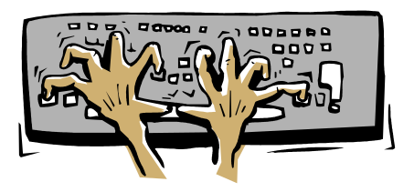
Java Programs using Breezy
Drop Down Boxes

Using BreezyGUI, write a Java program to accomplish the following tasks. The drop down boxes should resemble the samples shown.
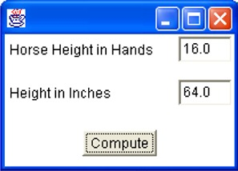
1. Given the height of a horse in hands, compute the height in inches. (One hand = 4 inches.)

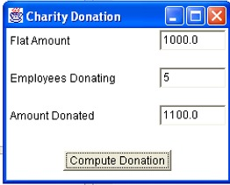
2. Each year a computer company donates monies to a children's charity based upon how many of their employees also donate. The company offers a flat amount each year plus an additional 2% of that flat amount for each employee who also donates (regardless of the amount donated by the employee). Ask for the flat amount and the number of employees who have donated. Compute the amount given to the children's charity for that year. Notice the "title" on the drop down box.

3. You are collecting information for a database on preferred college campuses. Ask the user to enter the name of a college, rate the college from 1 to 5 (5 being the highest rating), and state whether the user is male or female. Print a message to display this information. Note the manner of the display in the message box below.
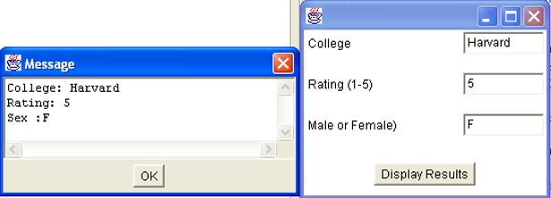
4. Write a program that takes the size of an angle in seconds. The program converts this value to the corresponding number of degree, minutes, and seconds and displays these values in a message box. (1 degree = 60 minutes, 1 minute = 60 seconds)

5. Crime Scene Investigates (CSI) collect evidence from a crime scene at a casino. Playing cards, found next to the body, are placed in a bag. Ask the CSI how many red playing cards were placed in the bag and how many black playing cards were placed in the bag. Write a program that displays the percentage of red cards found at the scene (rounded to the nearest 10th of a percent).(Hint: If you enter the number of cards as integers, multiply by 1.0 before dividing to change to double format and use setPrecision(1) before printing the output.)

6. During the CSI investigation, information is collected from witnesses. Write a program that collects the following data and displays the data in a message box on several lines:
Last name
First name
Occupation
Year of birth (an integer)
Phone number

7. Richard purchases a new radio-controlled vehicle from a seller on Ebay as a birthday present for his friend, Darrick. Upon receiving the vehicle, Richard discovers that his friend already owns this model. Richard decides to sell the vehicle on Ebay himself for $10 more than he was charged. Since Richard is new to Ebay, he must setup an account and pay the current installation fee of $5.85. In addition, Ebay charges a 2% charge for each item sold (based upon the sale price). Write a program that asks for the original price paid by Richard for the vehicle. In either a field or in a message box, display the amount of profit Richard will make on this re-sale (if any), to the nearest penny.

